BU External Staff Web Pages
The BU external staff web pages can be found here: http://staffprofiles.bournemouth.ac.uk Clicking on this link will take you to the following screen:
You do not need to log in and so please ignore the ‘log in’ at the top of the screen.
Input a surname in full into the ‘Search’ box and click on ‘Search’. You will then be presented with matches for that surname and you should select the one you want.
The profile for the selected person will appear. All information presented has been imported from BRIAN (Bournemouth Research Information and Networking) and so you cannot amend information here. If you wish to make changes to the information within your profile then the majority of this will be done through BRIAN. Any changes that are made on BRIAN will be uploaded overnight.

Please note however, any information in the ‘Overview’ section under the 'Profile' tab on BRIAN will not be transferred onto the staff profile pages.
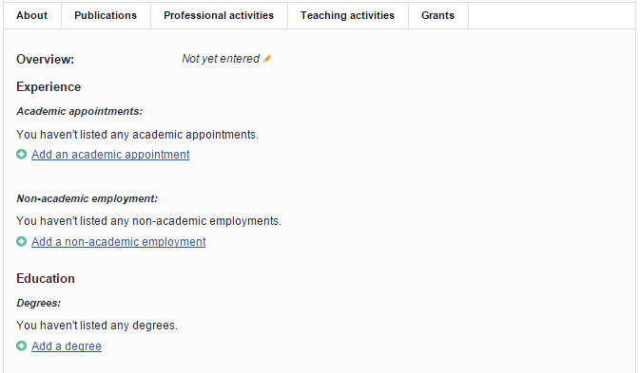
If you wish for your details like biography, qualifications or any relevant training to show on your staff profile page, please make use of the relevant fields under the ‘Professional Activities’ section on the ‘Home’ page.
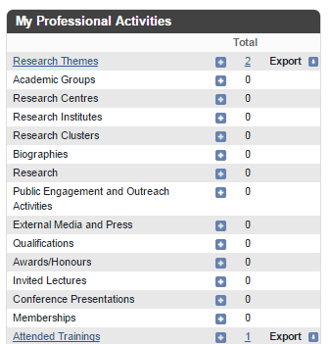

If you wish to amend your name then this must be done through HR. You can request a change to job title, phone number and room location through ‘Update your contact details’ on the staff intranet home page.
If you would like to change your existing photo, please ensure that it is between 250 x 250 and 350 x 350 pixels in size and be saved as username.thumbnail.jpg . For consistency these need to be a head and shoulders shot. Photos should be sent to BRIAN@bournemouth.ac.uk
There are a number of graphs and charts automatically populated within the external staff web pages. The publications chart is based solely on your publications entered into BRIAN. The ‘co-author network’ and ‘Map of Science’ are currently being reviewed to see how useful these may be.
You can input your keywords into BRIAN. However, these aren’t yet linked to the external profile pages but will be resolved shortly.

